A Tall Glass of Dirt

Materials –
- 1 water basin
- container that is lower than the edges of the water basin (must be heavy enough not to float in water – glass, metal)
- plastic cling wrap
- one very large elastic band (or several smaller ones)
- small/medium sized rock (or something else heavy enough to make the plastic wrap concave)
- dirt, salt, leaves, twigs, etc. (items to make your water dirty and inedible)
- heat source (strong, hot light, heat lamp, sun)

Safety Concerns –
If students are performing this experiment on their own, safety concerns regarding the temperature of the heat source must be considered. Make sure all apparatus are placed well away from traffic areas or where they could be knocked into.

Science Curriculum –
Grade 5, Cluster 2: Properties of and Changes in Substances
SLO: 5-2-08 – Demonstrate that changes of state are reversible through the addition or
removal of heat.

Mathematics Curriculum –
Grade 5, Shape and Space (Measurement)
SLO: 5.SS.4 – Demonstrate an understanding of capacity by measuring and recording
capacity (mL or L).

ELA Curriculum –
Grade 5, GLO 3.3 – Organize, Record, Assess
SLO: 3.3.4 – Develop New Understandings;
Assess knowledge gained through the inquiry or research process, form personal conclusions and generate new questions for further research or inquiry.

I chose this topic for my narrative because I wanted to show students, that once water evaporates, it does not automatically become the air we breathe. Osborne and Wittrock state, “Young children do have firmly held views about many science topics prior to being taught science at school” (p. 489-490, 1983). One of the examples they go on to use is the fact that many children believe the bubbles in boiling water are air (p. 490). This is a similar concept to the experiment I have chosen regarding the properties of and changes to substances. The molecules of water have separated but are able to reform and come back together to form a water molecule again. There are no added properties or molecules to alter the substance into anything else, it is simply water in its gaseous state, hydrogen and oxygen molecules only. The changes in properties of substances can be a difficult concept for students at the grade 5 level to grasp. For students, seeing one substance in different states; liquid, and gas in this instance, and reverting back again, is a more tangible method than discussing the theories from a text book. The type of experiment being conducted is a longitudinal study. This allows students to predict, observe, infer, and record data. These are all valuable skills to teach our students for their future scientific experiences.

A Tall Glass of Dirt

A troop of Boy Scouts was on a week long camping trip. Since the troop was doing a backwoods expedition, they had to limit the supplies they were bringing along because they had to carry everything on their backs. It was a very hot time of year, with the temperature reaching as high as 37 °C, the less they had to carry, the more they conserved their energy. Troop Leader Tom knew there was a creek nearby the camp site the boys would be using and had the boys only bring water to last them each a couple of days. This would be a major concern because of the high temperatures.
Knowing the small creek was nearby, Tom asked some of the boys to go to the creek and fill the wash basins with water. When the boys returned, Billy asked “Tom, what are we supposed to do with this dirty water? I don’t want to wash our dishes in it.” Tom was shocked and concerned to see the condition of the water. It was filled with dirt, twigs, algae, leaves, and it smelt funky. Now in a panic because of the lack of water, Tom thought they would have to turn around and cancel the trip.
Suddenly Luke, one of the older boys in the troop piped up and exclaimed, “Tom wait, I think I know what we can do!” Luke ordered the other boys to collect some items for him, “I need everyone to bring me there bowls or tin cans, I also need some big stretchy elastics, the plastic wrap the food is wrapped in and a couple of small rocks.” The boys were confused, how was this going to help them get water to drink, the water was still dirty?
Once Luke had all of the supplies he got to work building a contraption that looked like a little greenhouse. He then placed the various containers in the spot with the most direct sunlight.
Luke directed, “Nobody touch this all day long, we still have the entire day and the hottest part of the day is yet to come. Tonight we’ll check to see how much clean water we have collected.”
The boys were still confused, one of the younger boys, Jack, proclaimed, “Luke, the water is dirty and smells bad, how is the sun going to all of a sudden change that, especially when its trapped under the plastic? There is nowhere for the dirt and leaves to go!”
Luke used this opportunity to explain to all the boys, and Tom, his reasoning for what he was trying. He told the boys that his grandfather was an avid gardener and had a small greenhouse in their backyard. He asked if any of the boys had ever been in a greenhouse. “Yeah, I’ve been in one. My Mom made me go in one when she was buying flowers. I hated it, it was so hot and muggy in there. I started to sweat” Sean complained.
“That’s exactly right Sean” Luke commented. “A greenhouse is a building that you house plants in to help them grow during the colder months. It is a building that is covered in a thick plastic. The hot sun beats down on this plastic and gets absorbed into it. This makes it very hot and humid inside” Luke commented. He continued, “This small contraption that I have made is basically the same idea. I put it in the sun so it gets really hot. The water will evaporate and change from a liquid into a gas. The gas floats and rises, but when it hits the plastic wrap it will condense back into a liquid. This is now clean water. Does that make sense to you?”

- What is the significance of the rock?

- Draw a diagram of what you think the contraption looks like and the process taking place. Remember to use all of your supplies (large basin, plastic wrap, elastic, smaller glass/tin container and the rock.).
- Build the contraption and perform the experiment (This will take many hours to get a decent amount of water, over night).
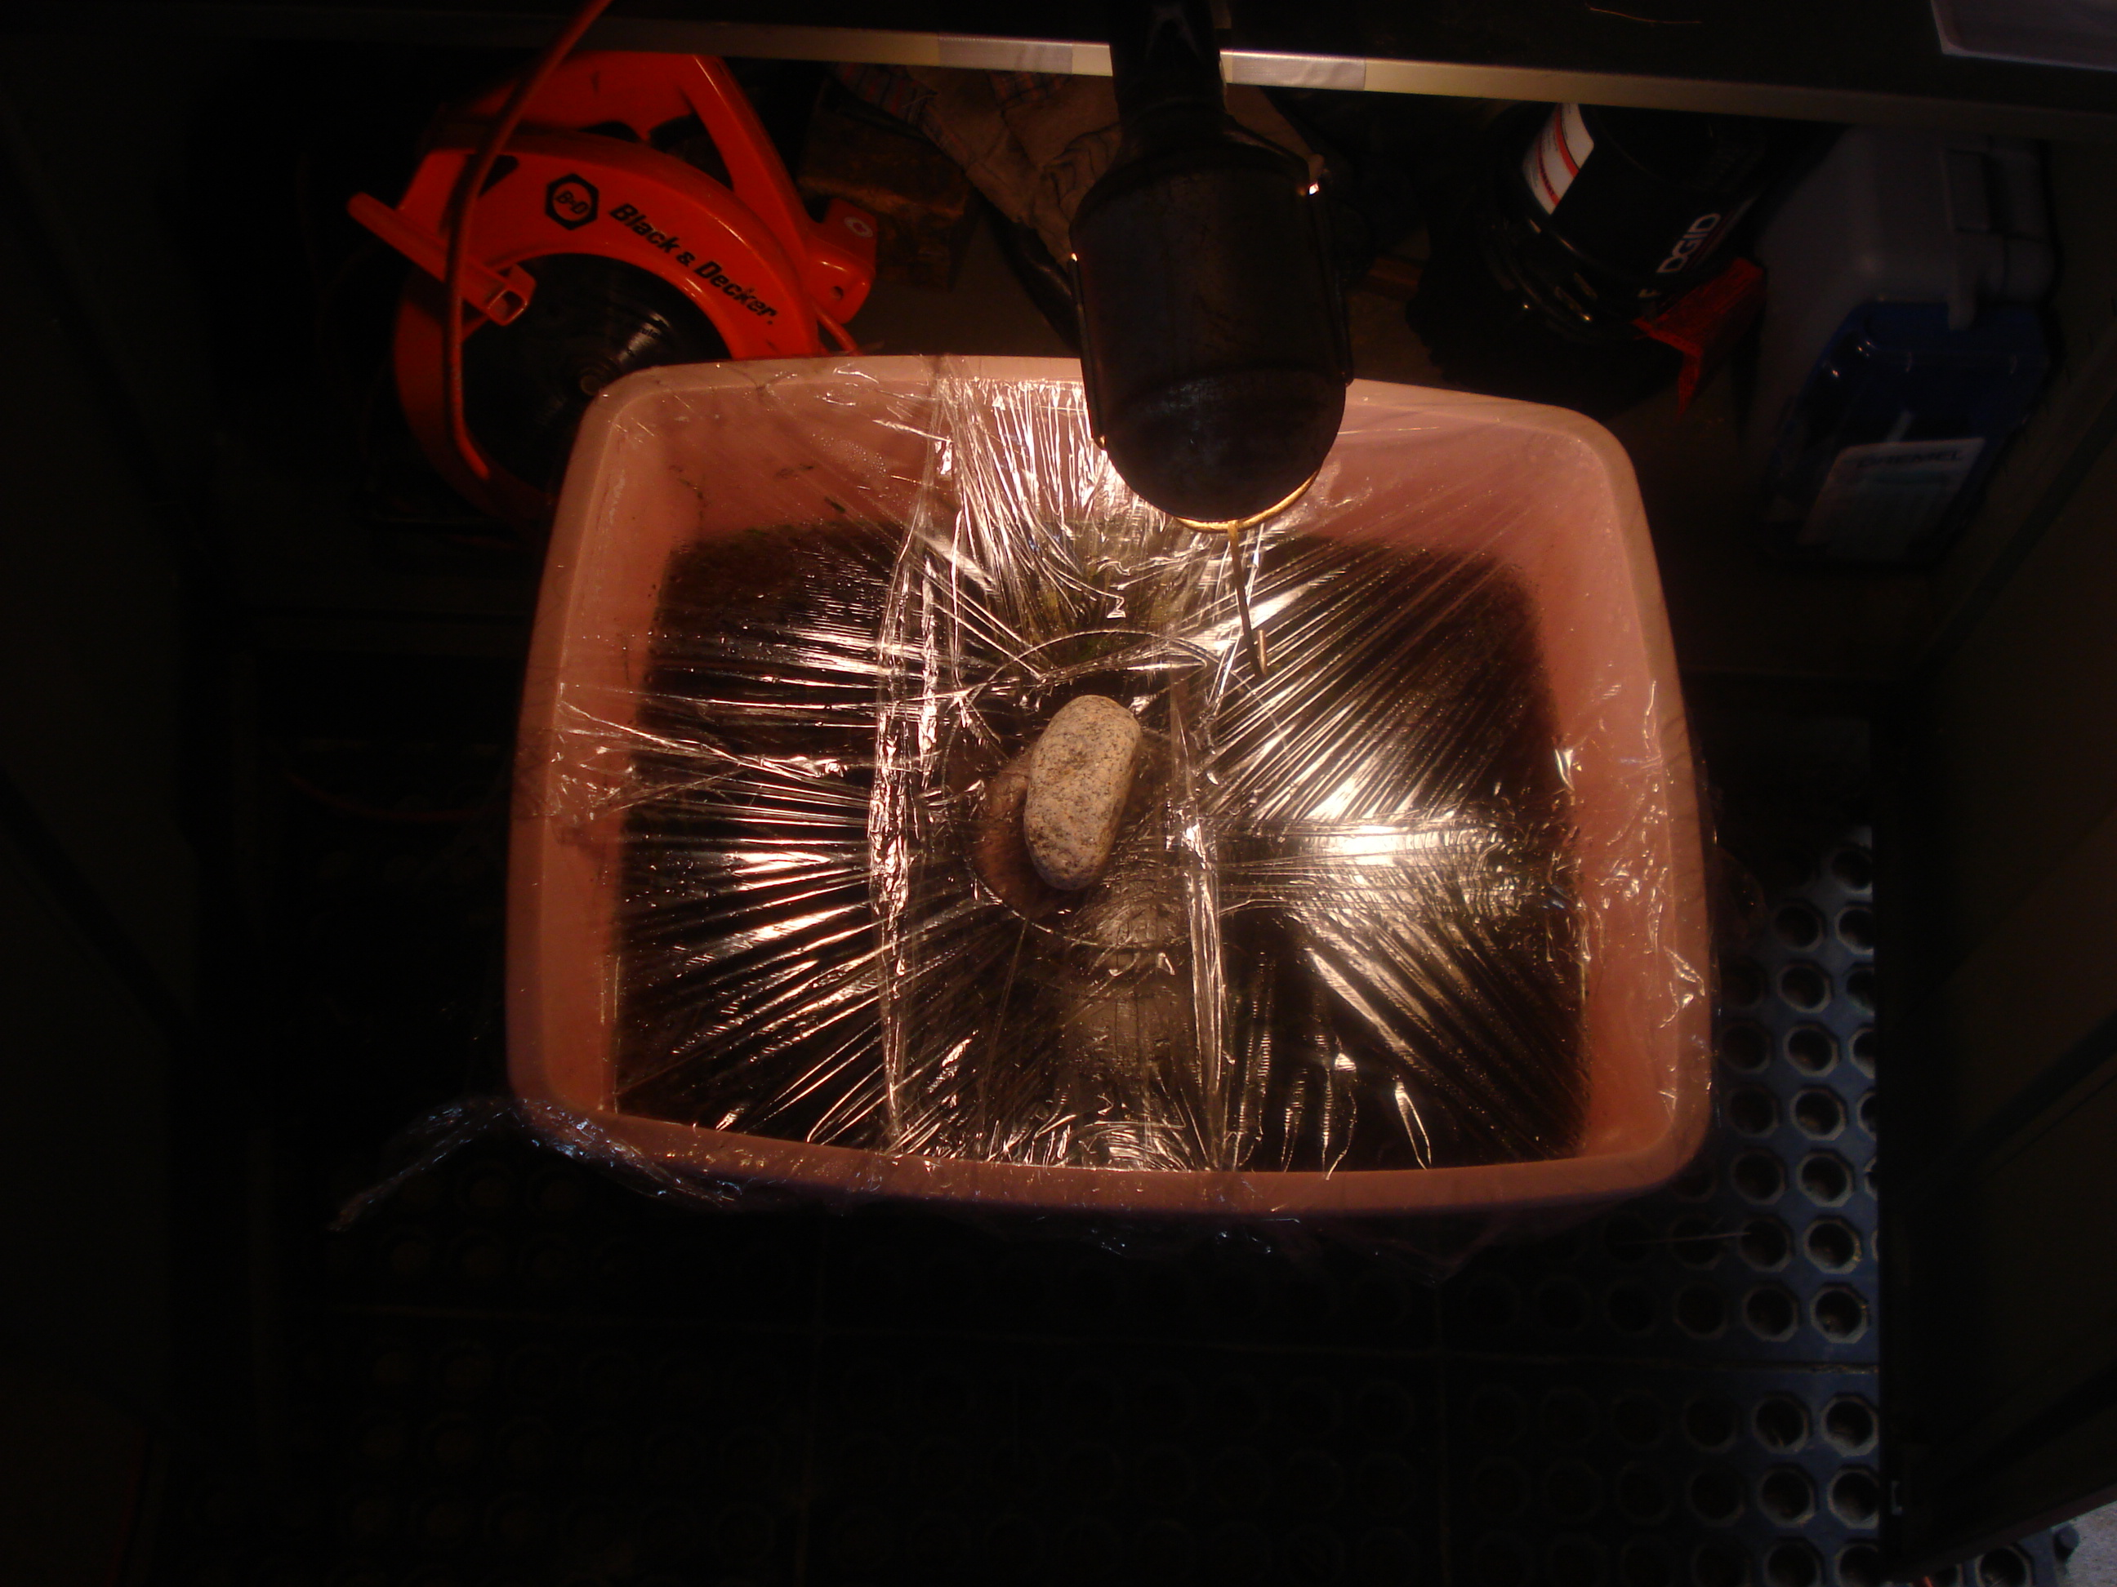

- Measure the amounts of clean water collected.
Morning | mL Collected
1
2
3

- Based on your findings, could Luke collect enough clean drinking water quickly enough to allow the troop to stay on their camping trip? Why?

- Is there a more productive way of getting clean drinking water? What is it and why is it more effective?

